H.T No
Regulations:
A22

Sreenidhi Institute of Science and Technology
(An Autonomous Institution)
Code No: 9B201 Date: 18-Feb-2025 (FN)

B.Tech I-Year II- Semester External Examination, February-2025 (Supplementary)
ENGINEERING MECHANICS (ME)

Time: 3 Hours Max.Marks:60

Note: a) No additional answer sheets will be provided.
b) All sub-parts of a question must be answered at one place only, otherwise it will not be valued.
c) Missing data can be assumed suitably.
Bloom's Cognitive Levels of Learning (BCLL)

Remember | L1 | Apply | L3 | Evaluate | L5
Understand | L2 | Analyze | L4 | Create | L6

Part - A Max.Marks: 6x2=12

Answer all QUESTIONS, EACH QUESTION CARRIES 2 MARKS.

 |  | BCLL | CO(s) | Marks
1 | Define Coplanar force system and Non-coplanar force system. | L1 | CO1 | [2M]
2 | What is coefficient of restitution? | L1 | CO2 | [2M]
3 | Differentiate between centroid and center of gravity. | L2 | CO3 | [2M]
4 | Define polar moment of inertia. | L1 | CO4 | [2M]
5 | What are the Zero force members in a truss? | L1 | CO5 | [2M]
6 | State D ‘Alembert’s principle. | L1 | CO6 | [2M]

Part – B Max.Marks: 6x8=48
ANSWER ALL QUESTIONS. EACH QUESTION CARRIES 8 MARKS.

 |  | BCLL | CO(s) | Marks
7. | A system of three forces acting on a body is shown in fig. Determine the magnitude, direction and position of the resultant force with respect to A.  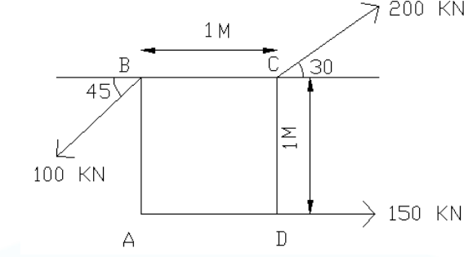 | L4 | CO1 | [8M]
 | OR
8 | (a) Explain free body diagram with example.  (b) State and prove Lami’s theorem. | L2 | CO1 | [8M]
9. | 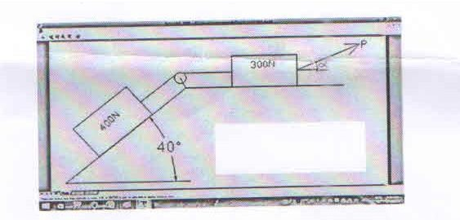  Determine the least value of the force ‘P’ to cause motion to impend rightwards. Assume the coefficient of friction under each block to be 0.3 and the pulley to be friction less. | L4 | CO2 | [8M]
 | OR
10 | 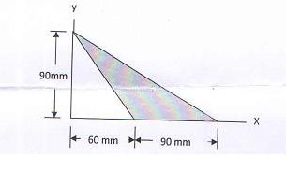  Determine area moment of inertia for the shaded portion with respect to given x and y axes shown in figure | L4 | CO2 | [8M]
11 | Determine the centroid of the area shown in Figure. with respect to the axis shown  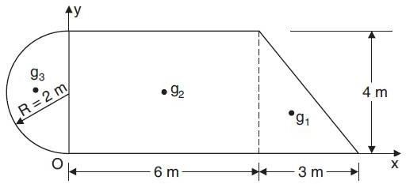 | L4 | CO3 | [8M]
 | OR
12 | Determine the centroid of the shaded area which is bounded by a straight line and circular as shown in Figure.  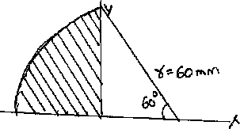 | L4 | CO3 | [8M]
13 | Explain method of joint and method of sections used in analysis of simple Trusses. | L3 | CO4 | [8M]
 | OR
14 | The bob of mass 1 kg of a simple pendulum of length ‘L’ meters rotates in a horizontal circular path of radius 0.25m with uniform speed. Find the time for one complete rotation. | L4 | CO4 | [8M]
15 | With neat sketches differentiate between motion of translation and motion of rotation. | L3 | CO5 | [8M]
 | OR
16 | An I-section as shown in Figure has the following dimensions in mm units: Bottom flange = 300 × 100 Top flange = 150 × 50 Web = 300 × 50 Determine mathematically the position of center of gravity of the section.  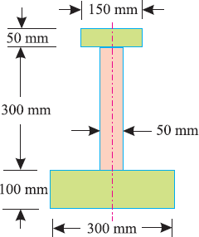 | L4 | CO5 | [8M]
17 | Write short notes on any TWO of the following:  - Radius of Gyration.  - Laws of friction.  - Parallel axis theorem | L3 | CO6 | [8M]
 | OR
18 | Prove the parallel axis theorem in the determination of moment of inertia of areas with the help of a neat sketch. | L3 | CO6 | [8M]

-- 00 -- 00 –

